
Azure Migrate Planning Guide

Cognizant Microsoft Business Group
20 North Wacker Drive #530
Chicago, IL 60606

Notice of Confidentiality ©2021 Cognizant Microsoft Business Group All rights reserved.

IS SUBJECT TO THE TERMS OF THE COGNIZANT MICROSOFT BUSINESS GROUP NON-DISCLOSURE AGREEMENT. NEITHER THIS DOCUMENT NOR ITS CONTENTS MAY BE REVEALED OR DISCLOSED TO UNAUTHORIZED PERSONS OR SENT OUTSIDE THE AFOREMENTIONED COMPANY WITHOUT PRIOR PERMISSION FROM COGNIZANT MICROSOFT BUSINESS GROUP.

Table of Contents
SUMMARY 2
VMWARE azure migrate ARCHITECTURE OVERVIEW 3
HYPER-V azure migrate ARCHITECTURE OVERVIEW 5
PHYSICAL azure migrate ARCHITECTURE OVERVIEW 6

SUMMARY
This document is intended to serve as a high-level guide for planning deployment of Azure Migrate components both on-prem and in the cloud for the purpose of migration. The information and checklists in this document are not exhaustive, they only contain common scenario information. We strongly urge you to explore the following Azure Migrate documentation.

General Azure Migrate documentation and support matrix:
Azure Migrate documentation | Microsoft Docs
Azure Migrate support matrix - Azure Migrate | Microsoft Docs
Support for physical server migration in Azure Migrate - Azure Migrate | Microsoft Docs

Azure Migrate capacity planning guide:
Build a migration plan with Azure Migrate - Azure Migrate | Microsoft Docs

Azure Migrate project setup guide:
Create and manage projects - Azure Migrate | Microsoft Docs

Azure Migrate VMWare agent-based architecture:
VMware agent-based Azure Migrate Server Migration | Microsoft Docs

Azure Migrate VMWare agent-less architecture:
VMware agentless Azure Migrate Server Migration | Microsoft Docs

Azure Migrate Hyper-V architecture:
Hyper-V Azure Migrate Server Migration | Microsoft Docs

Azure Migrate Physical architecture:
Migrate machines as physical server with Azure Migrate. | Microsoft Docs

VMWARE azure migrate ARCHITECTURE OVERVIEW
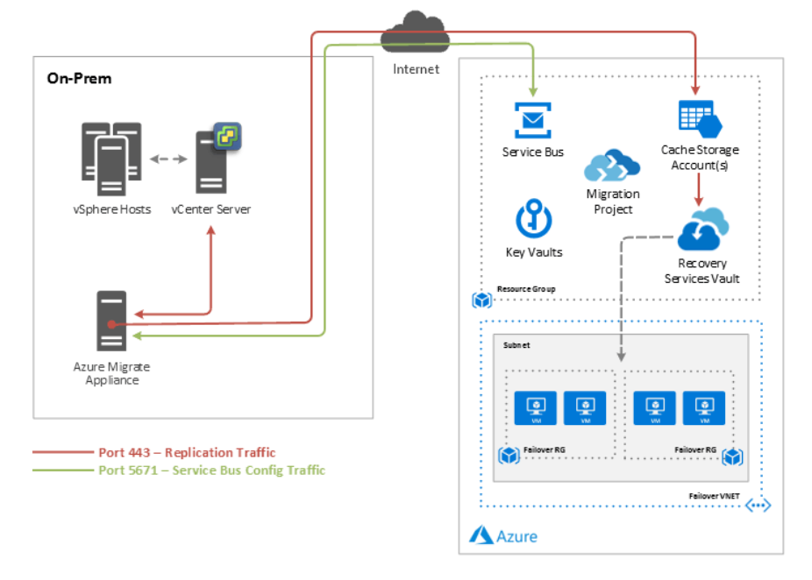
In most environments, the Azure Migrate Components are typically hosted on a single management server in the source environment. A preconfigured virtual appliance is available for quick deployment. The process server can be scaled out to allow for additional concurrent migration capacity.

Core Azure Migrate Components
- Configuration Server – Used for centralized migration management.
- Process Server – Used for caching, compression, and encryption. The process server can also be scaled out to allow for additional replication capacity per Azure Migrate instance.
  - Azure Migrate Project - An Azure Migrate project is used to store
discovery, assessment, and migration metadata collected from the environment you're assessing or migrating. In a project you can track discovered assets, orchestrate assessments, and perform migrations.
- Recovery Services Vault – The Azure cloud target storage entity that houses the source replication data to be used to create the new Azure VMs.
- Cache Storage Account – An Azure storage account used to cache incoming Azure Migrate replication data before being written to the Recovery Services Vault.

Network Communication
- HTTPS Port 443 – Used for replication management from the vCenter appliance to the replication appliance. Also used by the replication appliance to communicate outbound to Azure to facilitate replication.
- HTTPS Port 9443 – Used to send replication data from the VM to the process server.
- HTTPS Port 5671 – Used to send configuration traffic to Azure Migrate Project

This communication must be allowed on the network for successful operation of Azure Migrate components and replication.

HYPER-V azure migrate ARCHITECTURE OVERVIEW
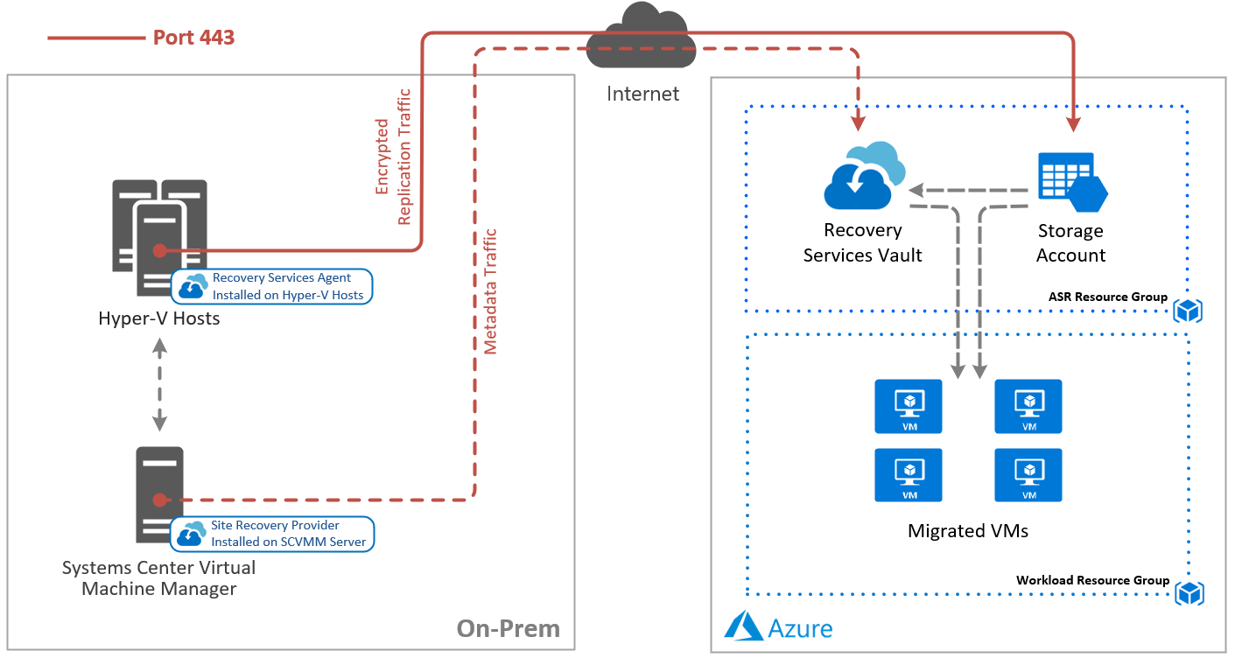
Core Azure Migrate Components

- Site Recovery Provider – Software installed on the Systems Center Virtualization Manger server. The provider connects to Azure Migrate project and sends VM metadata as well orchestrates migration with the Hyper-V hosts and Azure.
- Site Recovery Agent – Software installed on each Hyper-V host. The agent communicates with the Hyper-V service and sends replicated data to Azure storage.
- Recovery Services Vault – The Azure cloud target storage entity that houses the source replication metadata to be used to create the new Azure VMs.
- Target Storage Account – An Azure storage account used to store replicated disk data. Azure virtual machines are created using the replicated virtual disk data in the storage account, or if configured, the data is used to create new managed disks when the Azure VMs are created during failover.

Network Communication

HTTPS Port 443 – Used for replication management from the Site Recovery Provider on the SCVMM server to your Azure Migrate project. Also used by the Hyper-V hosts to communicate outbound to Azure storage to replicate disk data.

PHYSICAL azure migrate ARCHITECTURE OVERVIEW
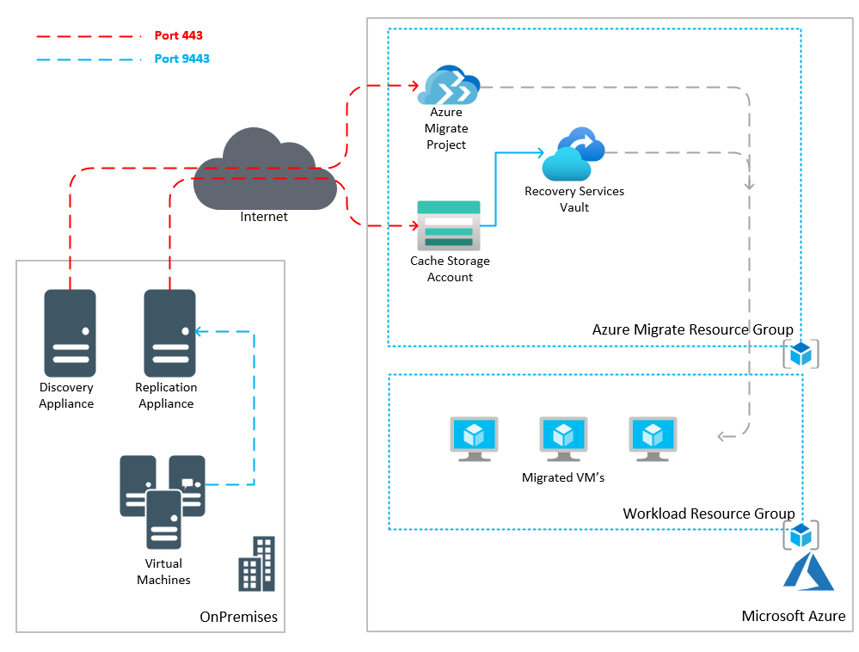
In most environments, the Azure Migrate Components are typically hosted on two virtual servers in the source environment. A virtual machine will need to be manually prepped for installation of the Azure Migrate appliance.

Core Azure Migrate Components

- Replication Appliance – Used for centralized migration management along with caching, compression, and encryption. The Replication appliance can also be scaled out to allow for additional replication capacity per Azure Migrate project.
  - Azure Migrate Project - An Azure Migrate project is used to store
discovery, assessment, and migration metadata collected from the environment you're assessing or migrating. In a project you can track discovered assets, orchestrate assessments, and perform migrations.
- Recovery Services Vault – The Azure cloud target storage entity that houses the source replication data to be used to create the new Azure VMs.
- Cache Storage Account – An Azure storage account used to cache incoming Azure Migrate replication data before being written to the Recovery Services Vault.

Network Communication
- HTTPS Port 443 – Used by the replication appliance to communicate outbound to Azure to facilitate replication.
- HTTPS Port 9443 – Used to send replication data from the VM to the process server.

This communication must be allowed on the network for successful operation of Azure Migrate components and replication.
Azure migrate PREREQUISITES
The following table outlines common prerequisites and considerations when deploying Azure Migrate and enabling replication of on-prem machines to the Azure cloud. We recommend in addition to reviewing this guide, also reviewing the Microsoft documentation specific to your migration goals.
Component | Requirement
Azure | ☐ Microsoft Azure account  ☐ Grant Cognizant MBG access to the appropriate subscriptions  ☐ A resource group for AzMigrate resources – Cognizant MBG will configure.  ☐ A storage account in the target region(s) to be used for the replication cache – Cognizant MBG will configure  ☐ A Log Analytics Workspace to be used to collect AzMigrate logs. – Cognizant MBG will configure  ☐ A virtual network in the target region(s) to test failover – Cognizant MBG will configure  ☐ Resource groups and virtual networks to land the migrated resources – Cognizant MBG will configure
Failback from Azure | Note: This is usually not applicable in a migration scenario.  ☐ A VPN or ExpressRoute connection from the Azure network to the on-prem site.  ☐ If you only have a S2S VPN connection back to the on-prem site, a temporary process server should be deployed in Azure. This can be created when you're ready to fail back and can be deleted after failback Is complete. This is not required if you have an Azure ExpressRoute connection.  A list of all requirements can be found at https://docs.microsoft.com/en-us/azure/site-recovery/vmware-azure-reprotect##before-you-begin.
VMware vSphere | ☐ Deploy vCenter Server to manage your ESXi hosts (if not existing).  ☐ Deploy the AzMigrate Process Server(s) in the same physical location and network as your vCenter Server or ESXi hosts.  ☐ Configure a service account to use for automatic discovery. This account should have a non-expiring password and at least read-only rights on the vCenter server.  ☐ Grant the automatic discovery service account local administrator rights on the servers to be protected. AzMigrate will require local admin credentials for software and dependency discovery. Optionally, an additional service account can be created and configured for this purpose.  Supported versions of VMware components can be found on the Microsoft VMware/Physical to Azure Support Matrix page.
Hyper-V | ☐ Deploy Systems Center Virtual Machine Manager (SCVMM) to centrally manage your Hyper-V hosts (if not existing).  ☐ Systems Center Virtual Machine Manager (SCVMM) and the Hyper-V hosts must have internet access over port 443 to Azure public endpoints.  ☐ You must install the Azure Site Recovery provider on the SCVMM server and the Azure Recovery Services Agent on the Hyper-V hosts and register them to a Recovery Services Vault in each target Azure region.
Configuration Server | In order to configure the on-prem Azure Migrate components, the following is required:  ☐ A virtual machine to host the Azure Migrate Component Services – Process Server, Configuration Server, Master Target Server. (Can be physical, but VM is preferred)  The server should have the following configuration:  - Windows Server 2012 R2 or later  - If using a VM, it should use a VMXNET3 network adapter  - The server should have a static IP address  - The server should not be a domain controller  - The host name of the server should contain 15 or less characters  - The Operating System should be in English only  - vSphere PowerCLI 6.0 or later should be installed on the server  - UAC should be disabled  - Print and File services and WMI should be allowed through the Windows Firewall, regardless of if the firewall is enabled or not.  ☐ The Configuration Server will require following network communication to be allowed:  - Temporary outbound access on HTTP port 80 during the setup of the Azure Migrate components to download MySQL  - Ongoing outbound access on HTTPS 443 for replication management  - Ongoing outbound access on HTTPS 9443 for replication traffic (this port can be changed)  - Allow IP address ranges for the Azure region of your resources. You need to allow the Azure Datacenter IP Ranges, and the HTTPS 443 protocol.  - The server will require access to the following URLs:  - *.hypervrecoverymanager.windowsazure.com  - *.accesscontrol.windows.net  - *.backup.windowsazure.com  - *.blob.core.windows.net  - *.store.core.windows.net  - http://cdn.mysql.com/archives/mysql-5.5/mysql-5.5.37-win32.msi  Note: Depending on number of migrating servers and churn rate, additional servers may be required to scale the deployment.
Azure Migrate Configuration Server Capacity Planning | The following should be considered:  ☐ Maximum daily change rate - A protected machine can only use one process server and a single process server can handle a daily change rate of up to 2 TB. As a result, 2 TB is the maximum daily data change rate supported for a protected machine.  ☐ The configuration server should be able to handle the daily change rate capacity across all workloads running on protected machines and needs sufficient bandwidth to continuously replicate data to Azure storage.  As a best practice, we recommend the configuration server be located on the same network and LAN segment as the protected machines. In the event this is not possible, the configuration server can be located on a different VLAN but all protected servers should have L3 network visibility.
All On-Prem Replicated VMs | ☐ The following common requirements should be met for on-prem virtual machines that are to be replicated to Azure:  - VMware Tools should be installed and running on VMware machines  - The OS disks should not exceed 2TB for VMware and 300GB for Hyper-V  - Individual data disks should not exceed 8TB in size when replicating to managed disks (recommended for VMware and physical machines, not supported for Hyper-V), and 4TB when replicating to a storage account (Hyper-V).  - Minimum of 2GB available disk space for component installation on VMware and physical machines  - If application consistent snapshots are required across VMs, port 20004 should be opened on the VM’s local Windows Firewall (VMware or physical machines only)  - Machine names should contain between 1 and 63 characters (letters, numbers, and hyphens). The name must start with a letter or number and end with a letter or number. After you've enabled replication for a machine, you can modify the Azure name.  - Note: If protected virtual machines have an iSCSI disk, then Site Recovery converts the protected VM iSCSI disk into a VHD file when the VM fails over to Azure. If the iSCSI target can be reached by the Azure VM, then it will connect to it and essentially see two disks – the VHD disk on the Azure VM, and the source iSCSI disk. In this case, you’ll need to disconnect the iSCSI target that appears on the Azure VM.  - Note: If the source VM has NIC teaming, it will be converted to a single NIC after failover to Azure.  - Common Limitations:  - Protection of VMs with encrypted disks is not supported. The VM must be decrypted first.  - Shared disk guest configurations are not supported  For a full list of requirements and limitations, please visit the Azure VM Requirements page.  For a full list of supported Operating Systems, please visit the Supported Operating Systems page.
Windows Protected VMs | ☐ The following common requirements should be met for on-prem Windows virtual machines that are to be replicated to Azure:  - The VM must be running a 64-bit operating system, Windows Server 2008 R2 or newer.  - The Operating System should be installed on the C:\ drive. The OS disk should be a Windows basic disk and NOT dynamic. Data disk(s) can be dynamic.  - Azure Migrate supports VMs with an RDM disk. During failback, Azure Migrate reuses the RDM disk if the original source VM and RDM disk is available. If they aren’t available, during failback Azure Migrate creates a new VMDK file for each disk.  - By default all the disks on a machine are replicated. To exclude a disk from replication, the Mobility service must be installed manually on the machine before you enable replication.  For a full list of requirements and limitations, please visit the Azure VM Requirements page.  For a full list of supported Operating Systems, please visit the Supported Operating Systems page.
Linux Protected VMs | ☐ The following common requirements should be met for on-prem Linux virtual machines that are to be replicated to Azure:  - /etc/hosts files on protected machines should contain entries that map the local host name to IP addresses associated with all network adapters  - If you want to connect to an Azure virtual machine running Linux after failover using a Secure Shell client (ssh), ensure that the Secure Shell service on the protected machine is set to start automatically on system boot, and that firewall rules allow an ssh connection to it.  - The host name, mount points, device names, and Linux system paths and file names (eg /etc/; /usr) should be in English only.  - Protection can only be enabled for Linux machines with the following storage: File system (EXT3, ETX4, ReiserFS, XFS); Multipath software-Device Mapper (multipath)); Volume manager: (LVM2). Physical servers with HP CCISS controller storage are not supported. The ReiserFS filesystem is supported only on SUSE Linux Enterprise Server 11 SP3.  - Azure Migrate supports VMs with an RDM disk. During failback for Linux, Azure Migrate doesn’t reuse the RDM disk. Instead it creates a new VMDK file for each corresponding RDM disk.  - Ensure that you set the disk.enableUUID=true setting in the configuration parameters of the VM in VMware. Create the entry if it doesn't exist. It's needed to provide a consistent UUID to the VMDK so that it mounts correctly. Adding this setting also ensures that only delta changes are transferred back to on-premises during failback, and not a full replication.  For a full list of requirements and limitations, please visit the Azure VM Requirements page.  For a full list of supported Operating Systems, please visit the Supported Operating Systems page.

